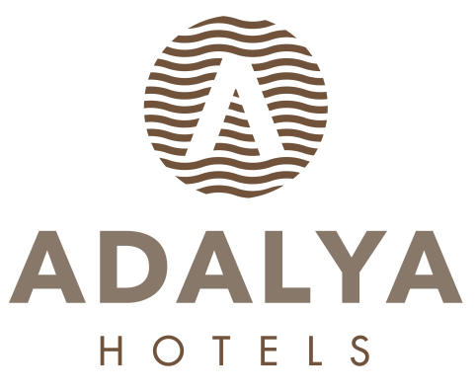
HOTEL FACT SHEET

- GENERAL INFORMATIONS:

HOTEL NAME : ADALYA OCEAN DELUXE HOTEL
LOCATION : EVRENSEKİ TURİZM MERKEZİ
KATEGORIE : 5 (FIVE) STARS HOTEL
ADRESSE : EVRENSEKİ / MANAVGAT / ANTALYA
TELEPHON : + 90 242 777 00 60 Pbx
FAKS : + 90 242 763 06 66
WEB PAGE : www.adalyahotels.com

E-MAIL : info@adalyaocean.com

- HOTEL TRANSPORTATION:
TO DISTANCE METHOD DURATION
SİDE CITY CENTER 10 km Shuttlebus / Taxi (+/-) 20 Min.
MANAVGAT CITY CENTER 12 km Shuttlebus / Taxi (+/-) 20 Min.

ANTALYA AIRPORT 65 km Taxi - Bus (+/-) 55 Min.

- ACCOMODATION:

TOTAL ROOM : 382 FLOORS : 5
TOTAL BED : 952 LIFTS :5 ALL ROOMS ARE WITH:
OPENING YEAR : 2013 Telephone
Hot Drinks Set-Up
Standard Double Rooms : 267 (+/- 30m²) (1-French Bed + 1-twinbed) LCD TV (Satellite)
Standard Double Rooms : 67 (+/- 30m²) (1-French bed or 2-twinbed) Mini bar
Family Rooms : 40 (+/- 40m²) (1-French bed + 2-twinbed) Safe Box
Handicap Friendly Rooms : 3 (+/- 30m²) (1-French bed + 1-twinbed) Balcony
Standart Superior Comfort Rooms ( summer) : 5 (+/- 30m²) (1-French bed + 1-twinbed)

- SPECIAL FEATURES:

Site Surface : 16.000 m² OPENING TIMES:
Outdoor Pool (open) summer : 800 m² 07: 00 / 20: 00
Children Pool (open) summer : 40 m² 07: 00 / 20: 00
Indoor Pool winter : 120 m² WITH HEATING SYSTEM 08: 00 / 19: 00
Aqua Park summer : 100 m² 3 Slides

Main Restaurant : 1.334 m² Indoor (+/-) 640 Person – Outdoor (+/-) 400 Person OPENING TIMES:
Ottoman A’ la Carte Restaurant : 120 m² (+/-) 60 Person 19: 00 / 21: 00
Italian A’ la Carte Restaurant : 120 m² (+/-) 60 Person 19: 00 / 21: 00
Mexican A’ la Carte Restaurant : 100 m² (+/-) 50 Person 19: 00 / 21: 00
Dolphin A la Carte Restaurant : 380 m (+/-) 200 Person open between 1.6-15.10 19: 00 / 21: 00
Anchor Pool bar summer : 150 m² (+/-) 100 Person 10: 00 / 24: 00
Dolphin Beach Bar summer : 380 m² (+/-) 200 Person 10: 00 / 18: 00
Lobby Bar : 480 m² (+/-) 350 Person (Indoor) and (+/-) 150 Person 10: 00 / 24: 00
Compass Bar : 240 m² (+/-) 250 Person (Indoor) and (+/-) 120 Person 24-hours
Mermaid Disco Bar : 308 m² (+/-) 200 Person 24: 00 / 03: 00
Hangout ( coffee house) summer : 20 m² (+/-) 10 Person 10: 00 / 16: 00
Game Hall : Billiards, Chess, Air hokey, Table soccer, Video games and Bowling (Extra charged)
Wellness, Beauty Center / SPA : 900 m² Turkish Bath, Sauna, Special massages, SPA, VİP Massages
Mini Club : For children between 4 -12 ages
Shopping Center : Jeweler shop, Market, Hair Dresser, Boutique, Leather shop, Silver Shop, Souvenier, Photo shop, Bag Shop.
Dorado Meeting Hall : 600 m² (+/-) 460 Person
Moss Meeting Hall : 180 m² (+/-) 50 Person
Gomina Meeting Hall : 180 m² (+/-) 50 Person
Meeting Equipment : Barco vision, Flip chart, Screen, Sound System, microphone system,
Cleaning Services : Daily Room cleaning and Towel change available.
Beach : 100 meter distance till the beach, Sand & Pebble mixed has Blue Flag Certification, it is a private beach.

- SPORT, FUN, HEALTH & BEAUTY SERVICES:

Extra Charged Free of Charge
* Billiard * Daily Activities (Special Games)
* Game room with video games * Animation Shows
* Massage & Peeling – Foam, * Fitness Center
* Skin Care * Special Gala Party, 1 time in every 2 weeks
* Hair Dresser * Turkish bath, Sauna,
* Beauty center * Table Tennis, Dart, Beach Volley, Boccia
* Water Sports in Beach (Parachute, Boat, Cano, Wind Surf * Aerobic, Gymnastics, Water Gym
* Mini Club between 4–12 old kids, Mini disco
- GUESTSERVICES :

Extra Charged Free of Charge
* Doctor * Safe in the Room
* Jeep, car rental, Bicycle and baby care rental * Mini Library
* Shopping center * Wireless in all areas ,rooms
* Airport Transfer * Mattress and Umbrellas at the Beach and Pool
* Laundry * Beach Towel
* Baby Care * Animation Shows
* Telephone and fax
* Room Services

- USEFULL INFORMATIONS:

*** Use full Credit Cards : Visa, Master card, Maestro card,
*** Languages : Turkish is the official language. German, English and Russian are spoken
*** PETS ARE NOT ALLOWED.

