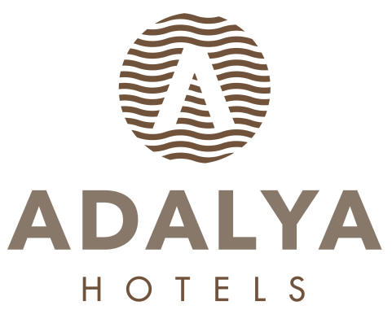

ADALYA OCEAN DELUXE

ULTRA ALL INCLUSIVE WINTER SEASON
FOOD & BEVERAGE CONSEPT

BREAKFAST 07: 00 - 10: 00 ATLANTIS MAIN RESTAURANT OPEN BUFFET
LATE BREAKFAST 10: 00 - 11: 00 ATLANTIS MAIN RESTAURANT OPEN BUFFET

LUNCH 12: 30 - 14: 30 ATLANTIS MAIN RESTAURANT OPEN BUFFET
DINNER 19: 00 - 21: 00 ATLANTIS MAIN RESTAURANT OPEN BUFFET + KINDER BUFFET
MIDNIGHT BUFFET 21: 30 - 07: 00 RESTAURANT LA VELA MINI BUFFET

SNACK SERVICES

PASTRY 11: 00 - 22: 00 COMPASS CAFE & BAR DRY AND WET BAKERY & ICE CREAM
ICE CREAM 12: 30 - 16: 00 COMPASS CAFE & BAR
FLAT-BREAD 11: 00 - 16: 00 COMPASS CAFE & BAR
WAFFLE 14: 30 - 16: 00 COMPASS CAFE & BAR
BAKED POTATOES 12: 30 - 16: 00 COMPASS CAFE & BAR

A’LA CARTE RESTAURANTS

CEVAHİR A’LA CARTE . 19: 00 - 21: 00 SPECIAL MENU OTTOMAN CUISINE RESERVATION
RISTORANTE LA VELA 19: 00 - 21: 00 SPECIAL MENU ITALIAN CUISINE RESERVATION
PICANTE A’LA CARTE 19: 00 - 21: 00 SPECIAL MENU MEXICAN CUISINE RESERVATION
**The days that are open will be confirmed by the Guest Relation department.

BARS

LOBBY BAR 10: 00 - 24: 00 ALL LOCAL & SOME IMPORT ALCOHOLIC-NONALCOHOLIC DRINKS
COMPASS CAFE & BAR 24 HOURS ALL LOCAL & SOME IMPORT ALCOHOLIC-NONALCOHOLIC DRINKS
MERMAID DISCO & BAR 24: 00 - 03: 00 ALL LOCAL & SOME IMPORT ALCOHOLIC-NONALCOHOLIC DRINKS
3 NIGHTS A WEEK
MINI BAR DAILY FILLED WITH SOFT DRINKS, BEER
ROOM SERVICE 24 HOURS ALL FOOD & BEVERAGE ARE EXTRA.

**************************************************************************************************

- IN ULTRA ALL INCLUSIVE CONSEPT ALL DRINKS ARE SERVED IN GLASS

- BOTTLE DRINKS WILL BE CHARGED.

- ROOM SERVICE IS FOR CHARGE.

- ALCOHOL WILL BE NOT SERVED TO PERSONS UNDER AGE OF 18.

- WITH PRE RESEVERTION FOR A’LA CARTE RESTAURANTS, DURING THE STAY 1 TIME FREE OF CHARGE

- PETS ARE NOT ALLOWED.

- DEPENDING ON WEATHER CONDITIONS HOTEL RESERVES THE RIGHT TO CHANGE DATE, PLACE AND TIME OF OUTLETS.

