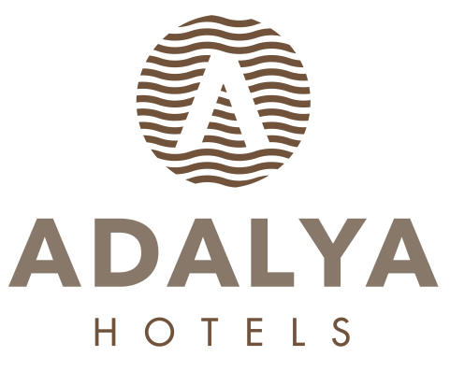

ADALYA ELITE LARA

ULTRA ALL INCLUSIVE SUMMER SEASON
FOOD & BEVERAGE CONCEPT

BREAKFAST 07: 00 - 10: 00 ART MAIN RESTAURANT OPEN BUFFET
LATE BREAKFAST 10: 00 - 11: 00 ART MAIN RESTAURANT OPEN BUFFET

LUNCH 12: 30 - 14: 30 ART MAIN RESTAURANT OPEN BUFFET + KIDS BUFFET
DINNER 19: 00 - 21: 30 ART MAIN RESTAURANT OPEN BUFFET + KIDS BUFFET
MIDNIGHT BUFFET 22: 30 - 07: 00 ART MAIN RESTAURANT MINI BUFFET

SNACK SERVICES 12: 30 - 16: 00 HEAVEN POOL SNACK CORNER FAST FOOD
SNACK SERVICES 12: 30 - 17: 00 RIVER SIDE BEACH SNACK COR. FAST FOOD
PASTRY 16: 00 - 23: 00 LA VANILLA PATTESERİA DRY AND WET BAKERY & ICE CREAM
ICE CREAM 12: 30 - 16: 00 HEAVEN BAR
FLAT-BREAD 11: 00 - 16: 00 GÖZLEME HOUSE
WAFFLE 12: 30 - 17: 00 WAFFLE CORNER

A’LA CARTE RESTAURANTS

BOSPHORUS A’LA CARTE 19: 00 - 21: 30 SPECIAL MENU OTTOMAN CUISINE RESERVATION
BASILICO A’LA CARTE 19: 00 - 21: 30 SPECIAL MENU ITALIAN CUISINE RESERVATION
CAI A’LA CARTE 19: 00 - 21: 30 SPECIAL MENU ASIA CUISINE RESERVATION
ESPECIAS A’LA CARTE 19: 00 - 21: 30 SPECIAL MENU MEXICAN CUISINE RESERVATION
HALIKARNAS A’LA CARTE 19: 00 - 21: 30 SPECIAL MENU SEA FOOD RESERVATION/EXTRA

BARS

LOBBY EAST BAR 09: 00 - 24: 00 LOCAL & SOME IMPORT ALCOHOLIC-NONALCOHOLIC DRINKS
LOBBY WEST BAR 16: 00 - 24: 00 LOCAL & SOME IMPORT ALCOHOLIC-NONALCOHOLIC DRINKS
MAHALL BAR 24 HOURS LOCAL & SOME IMPORT ALCOHOLIC-NONALCOHOLIC DRINKS
HEAVEN POOL BAR 10: 00 - 18: 00 LOCAL & SOME IMPORT ALCOHOLIC-NONALCOHOLIC DRINKS
RIVER SIDE BEACH BAR 10: 00 - 24: 00 LOCAL & SOME IMPORT ALCOHOLIC-NONALCOHOLIC DRINKS
PIER BAR 10: 00 - 24: 00 BEER, WINE AND LOCAL SOFT NONALCOHOLIC DRINKS
ANGEL NIGHT CLUB 23: 30 - 02: 00 LOCAL & SOME IMPORT ALCOHOLIC-NONALCOHOLIC DRINKS
3 NIGHTS A WEEK INSIDE AND 3 NIGHTS A WEEK OUTSIDE WITH NIGHT BEACH PARTY
MINI BAR DAILY FILLED WITH WATER, SOFT DRINKS, BEER
ROOM SERVICE 24 HOURS ALL FOOD & BEVERAGE ARE EXTRA.
LUNA PARK 18: 00 - 20: 00

**************************************************************************************************

- IN ULTRA ALL INCLUSIVE CONCEPT ALL DRINKS ARE SERVED IN GLASS

- BOTTLE DRINKS WILL BE CHARGED.

- ROOM SERVICE IS EXTRA CHARGED.

- ALCOHOL WILL BE NOT SERVED TO PERSONS UNDER AGE OF 18.

- FOR 7 NIGHTS ACCOMODATION 1 TIME 1 RESTAUTANT A LA CARTE IS FREE OF CHARGE WITH THE PRE RESERVATION

- PETS ARE NOT ALLOWED.

- HALIKARNAS SEFOOD RESTAURANT WILL BE OPEN BETWEEN 01.06 / 15.10

- DEPENDING ON WEATHER CONDITIONS HOTEL RESERVE THE RIGHT TO CHANGE DATE, PLACE AND TIME OF OUTLETS.

